This Policy applies to all Promoted Post Holders
employed on SNCT Pay Scales

Education Division

Job Sizing Policy

APPROVED BY LNCT

3rd October 2023
Index

Page 3 Introduction – Job Sizing Process
- Job-Sizing Team

Page 4 2. New Posts
3. Vacancies

Page 5 4. Post Holder Initiating a Review
5. Council Initiated Reviews

Page 6 6. Verification of Content
7. Notification of Job-Sizing Result

Page 7 8. Temporary Funding and Job Sizing
9. Right of Appeal

Page 8 10. Local Agreements
10.1 Salary scale - permanent Headteacher of two schools
10.2 Headteachers Taking on Additional Schools on a Temporary Basis

Page 9 10.3 DHT Equalisation Agreement (DHT parity)
10.4 Principal Teachers of Guidance
10.5 Teaching Time

Page 10 10.6 Direct Line Management of Support Staff in Secondaries
10.7 Special Circumstances

APPENDICES

Page 11 | Appendix 1: Job-Sizing Co-ordinators - August 2023
Page 12 | Appendix 2: Flowchart - Job Sizing Process – New or Vacated Posts
Page 13 | Appendix 3: Flowchart - Job Sizing Process – Postholder Request – Biannual Review
Page 14 | Appendix 4: How to Complete your Questionnaire
Page 15-17 | Appendix 5: Review Criteria
Page 18-19 | Appendix 6: Job Sizing Request Form
Page 20-22 | Appendix 7: Frequently Asked Questions
Page 23-40 | Appendix 8: Job Sizing Questionnaire & link to SNCT Guidance

Protocol for Job-Sizing of Promoted Posts

INTRODUCTION

The Scottish Negotiating Committee for Teachers (SNCT) reached agreement on the method to be used in determining the appropriate remuneration for promoted posts. The means by which Councils evaluate posts is known as the toolkit. The toolkit measures a number of factors when determining the weightings for a post and the overall score (job-sizing points) is used to identify the appropriate point on the pay scale. This information is made available to promoted post holders when a post is job-sized. The Job Sizing Circular (SNCT 28), details the information required for job-sizing posts and provides comprehensive guidance for the completion of the job-sizing questionnaire.

This document sets out the procedures to be followed when promoted posts in Secondary, Primary and Special Schools are to be job-sized or re-sized and will be known as “The protocol for job-sizing of promoted posts”. This protocol has been agreed with the teaching unions and is in keeping with
the requirements of the 21st Century Agreement and National Circulars.

JOB-SIZING PROCESS

- JOB-SIZING TEAM

- The Job-Sizing Team consists of trained Job-Sizing Co-ordinators from both Management and Teachers’ trade unions, nominated by the LNCT (Appendix 1).

- Job-Sizing Co-ordinators must have received training either directly by the SNCT trainers or locally by other trained job sizing co-ordinators until the next SNCT training can be attended.

- At least two Job-Sizing Co-ordinators (one Management and one Teachers’ side) would always be involved in any job sizing/review.

- The role of the Job-Sizing Team is to work together to ensure that the job-sizing process is efficient, fair and transparent.

- The Job-Sizing Team are tasked to:

- Consider applications for Review and use the SNCT Review Criteria to decide whether job-sizing of a post is necessary.

- Provide advice on interpretation of terms and/or assistance with completion of the relevant documentation.

- Validate and sign off all information submitted in the Job-Sizing Questionnaire.

- Process all data through the Job-Sizing Toolkit.

- Meet on a regular basis to prioritise and review posts.

- NEW POSTS

- New posts are defined as posts that have not previously existed.

- New posts will be established and job-sized, following approval from the relevant Head of Service in accordance with agreed management structures, in line with the Service Review Policy. Head Teacher/Senior Education Manager will be asked to complete the job-sizing questionnaires for new posts and liaise directly with the Job-Sizing Team. Both the Education Department and Head Teacher/Senior Education Manager will be informed of the relevant grade for new posts. Once job-sized the normal recruitment procedures will apply. (Recruitment & Selection Policy)

- SNCT Section 2: 1.69 Where a teacher is appointed to a promoted post with a view to preparing for the opening of a new school/the expansion of an existing school, or where a teacher already serving in the school is required to make the preparations and is to continue to serve in the post after the opening of the school/while the expansion is taking place, the salary of the teacher may be increased by such amount as the council consider appropriate.

In such circumstances the Head of Education will liaise with and take advice from HR Team Leader, a Trade Union representative and the Job Sizing team. A full audit trail of the decision shall be retained in the relevant school folder. (LNCT 01.06.23)

- VACANCIES

- Where an existing post becomes vacant or where a long-standing vacancy is to be filled, the Head Teacher/Senior Education Manager shall, in the first instance, notify the Job-Sizing Team via the Job-Sizing Mailbox (jobsizing@eastlothian.gov.uk).

- All posts will be reviewed to determine if they require to be evaluated, prior to being advertised. It is therefore essential that the Job Sizing Coordinators are notified of the impending vacancy as soon as possible. A post cannot be advertised until job-sizing has been concluded.

- When the requirements of SNCT 28 are met for the sizing of a post then the steps outlined in Appendix 2 should be followed. If there is no requirement to re-size an existing post then the normal method of recruitment will apply.

- For posts of Depute and Principal Teacher, the Head Teacher/Senior Education Manager must sign the job-sizing questionnaire to confirm that the information provided accurately reflects the remit of the post and forward directly to the Job-Sizing Team electronically via Job-Sizing Team email inbox (jobsizing@eastlothian.gov.uk).

- For Head Teacher posts, the Head of Education (or their designated officer) must sign the job-sizing questionnaire to confirm that the information provided accurately reflects the remit of the post and forward directly to the Job-Sizing Team electronically via Job-Sizing Team email inbox (jobsizing@eastlothian.gov.uk).

- In reviewing the questionnaire the Job-Sizing Team will take account of the remits, whole school data, SNCT 28 criteria (in the case of re-sizing) and the potential impact on other promoted posts within the school. In the case of a Head Teacher post meeting the criteria, the relevant Depute Head Teacher posts must also be job-sized and vice-versa.

- Any anomalies will be discussed and resolved at this point with the Head Teacher/Senior Education Manager.

- POSTHOLDER INITIATING A REVIEW

- In accordance with SNCT 28, a post can be reviewed at the request of the post holder or the Education Department. Where a post holder believes a review appears appropriate they should initially discuss this with their Head Teacher/Line Manager. There are two occasions, during the year, identified for the purpose of reviewing posts. These are a) in November with implementation from 1 February of the following year and b) May with implementation from 1 August, the same year. A post will only be reviewed once in any twelve-month period.

- As per SNCT 28, the table below details the criteria for initiating a review.

TYPE A CHANGES | AUTOMATIC REVIEW
TYPE B CHANGES | Requires at least one other change of Type B or two other changes of Type C before a review can take place.
TYPE C CHANGES | Requires three other changes of Type C before a review can take place.

- Where the above criteria are met, the post holder should complete the ‘Job Sizing Review Request Form’ (See Appendix 6) and return this to the Job Sizing Team via their line manager. The post holder should identify the SNCT 28 criteria against which they are requesting the review of their post. Where the Job Sizing Team believe there is a need for a review, this will be discussed with the post holder and if applicable, they will be asked to complete a job sizing questionnaire and return this to the Job Sizing Team for their post to be sized.

- The completed questionnaire should then be signed off by the Head Teacher/Senior Education Manager and validated by the Job-Sizing Team. The completed questionnaire will then be processed through the toolkit.

- There may be cases where a post holder is not employed within the Education Department. These will be considered on an individual basis.

- COUNCIL INITIATED REVIEWS

- The Council may initiate a review of one or more promoted posts if there is an indication of a change to the whole school data and/or the responsibilities of a post where there is a likelihood of the review resulting in a change to the job-size score (e.g. following annual Census). A Head Teacher can request that the Council initiate a review if there is a reallocation of areas of responsibility within their setting. The Service Review Team should be advised to determine whether or not the changes warrant a formal Service Review.

- An annual desktop exercise will be undertaken by the Job Sizing Coordinators staff each year to determine whether the Review Criteria in Appendix 5 has been met. Where thresholds have been met and/or significant changes have occurred, a review will be undertaken.

- Any review will be undertaken in partnership with the Trade Unions and a job-sizing exercise will follow.

- Any resulting change to salary will be implemented on the 1st February or 1st August following the review.

- Cash conservation of salary will be applied in accordance with the prevailing SNCT Conditions of Service where there is a resulting grade drop.

- VERIFICATION OF CONTENT

- When validating information provided on the Job Sizing Questionnaire the Job Sizing Coordinators will refer to:

- Whole school data collated after each September Census
- Budget Information Provided by Schools Finance
- School Improvement Plan
- School Timetable
- SQA Exam Presentation Reports (previous 2 years)

- The co-ordinators will validate entries in the questionnaire and ensure that there has been no double counting of responsibilities.

- Consideration will be given to whether changes to the whole school data and/or responsibilities of the post could have a possible impact on the remit and/or responsibilities of any other post in the school, which may thus require to be reviewed at the same time.

- If a questionnaire cannot be validated, the co-ordinators will provide a rationale to the postholder in writing. The co-ordinators may ask for the questionnaire to be resubmitted with additional supporting documents.

- NOTIFICATION OF JOB-SIZING RESULT

- Only once the Job Sizing Questionnaire had been validated, will the information provided be processed using Job-Sizing Toolkit. The Job-Sizing Team will notify the Head Teacher/Senior Education Manager of the outcome. It is the Head Teacher’s responsibility to communicate outcomes timeously with relevant post holders, where appropriate.

- It should be noted that the outcome may lead to;

- No change to pointage with no change to grade.
- Increase pointage with no change to grade.
- Increase pointage with change to grade.
- Decrease pointage with no change to grade.
- Decrease pointage with change to grade.

- Grade changes for vacancies, or grades determined for new posts created and posts changed under Service Review, will apply upon the agreed date for the commencement of duties.

- The Service Review Team (new posts only), relevant HR advisor and Schools Finance Business Partner should also be informed of new or changed grades.

- Any change to salary resulting from bi-annual job-sizing reviews will be effective depending on what time of the year the job-sizing questionnaire is submitted;

- November submission – effective from 1 February the following year.

- May submission – effective from 1 August, the same year.

- Where there is a change of grade, the Head Teacher/Senior Education Manager must complete the Council’s Change of Circumstances form with the appropriate effective date as above.

- Please note there is no scope for backdating as a result of a job-sizing review.

- Contact details for the Job-Sizing Team can be found on Appendix 1.

- TEMPORARY POSTS AND JOB SIZING

There may be occasions when authority might be given to the creation of additional promoted posts using external funding streams. For example, Pupil Equity Funds. When such additional promoted posts are being considered there are a number of factors that have to be taken into account when considering the associated remits:

- No management responsibility can be claimed for staff not funded from core budget.

- Due to the temporary nature of the funding no responsibility for management of a budget can be delegated to a post.

- There can be no double counting of remit/responsibilities.

- If posts are continued beyond temporary funding then they require to be re-evaluated as permanent posts.

- RIGHT OF APPEAL

- There is no mechanism to appeal the outcome of the job-sizing of a post unless the postholder is of the view that the process set out in this policy and procedures document has not been followed correctly.

- A postholder wishing to appeal must do so within ten working days of the job sizing outcome communication by their Head Teacher. The appeal must be in writing to the Service Manager, Strategy & Operations setting out clearly at which stage in the process the perceived error has occurred.

- The Service Manager, Strategy and Operations will respond to the appeal within 10 working days.

- There are two possible outcomes from an appeal:

- The appeal is upheld and remitted back to the co-ordinators to re-size;
- The appeal is not upheld

- No provision in this policy will prejudice an employee’s rights under the approved Grievance Procedure.

- LOCAL AGREEMENTS

10.1 Salary scale for candidates appointed to the position of permanent Headteacher of two schools

Where a candidate successfully secures the permanent post of Headteacher for two schools this will be job-sized on the combined figures for both schools and the following will apply:

- Where the total roll of the two schools is 150 or less there will be the addition of one scale point within the Depute Headteachers and Headteachers salary spine. e.g. where the job-sizing toolkit places the post at DHT/HT 3, one additional scale point will be added and the salary scale for that post will be DHT/HT 4

- Where the total roll of the two schools is 151 or more there will be the addition of two scale points within the Depute Headteachers and Headteachers salary spine. e.g. where the job-sizing toolkit places the post at DHT/HT 3, two additional scale points will be added and the salary scale for that post will be DHT/HT 5.

10.2 Headteachers Taking on Additional Schools on a Temporary Basis
- Where the roll of the additional school is less than 50% of the roll of the substantive school of the post holder, one Salary Point will be added.
E.g. where the substantive post holder’s grade is 6 and the role of their school is 120 and the additional HT salary is Scale Point 4 and the role of that school is 50, then the substantive post holder’s salary will increase one point to Scale point 7.
- Where the roll of the additional school is 50% or more of the substantive school two circumstances may apply:
- The additional school HT salary is the same or less than the substantive post holder’s, two Scale Points will be added to that of the substantive post holder.
e.g. if the substantive post holder’s Scale Point is 9 with a school roll of 450 and the post holder’s additional school is Scale Point 8 with a school roll of 350, two points will be added to the substantive post holder’s salary, increasing the Scale Point to 11.
- Where the additional school HT salary is higher than the substantive post holder’s salary, the Scale Point for the HT will be plus two points of the additional school’s HT salary.
E.g. where the substantive post holder’s Salary Scale is 8 with a school roll of 300 and the post holder’s additional school salary is 10 with a school roll of 500, two Scale Points will be added to the additional school’s HT salary therefore increasing the Scale Point from 8 to 12.
- Exceptionally, where a Headteacher takes over the responsibility for an additional school which requires significant support and improvement, the Head of Education may determine that 2 or more additional salary points are added to that Headteacher’s substantive salary, for the duration of that additional responsibility.

10.3 DHT Equalisation Agreement (DHT parity)

- At LNCT on 1st June 2023, it was agreed that, wherever possible, all DHTs in a setting should be the same grade to facilitate sustainability and training by enabling remits to be easily transmitted and shared. This also contributes towards equity and equality of pay.

- DHT parity also has the further advantage of keeping things in line when one incumbent moves on. Whenever re-evaluation is deemed necessary, the whole DHT job family should be reviewed.

- Job Sizing Co-ordinators will strive to achieve parity through legitimate allocation of roles & responsibilities.

- There may be circumstances when equalisation is not appropriate, e.g. DHT of a special provision.

10.4 Principal Teachers of Guidance

Timetabled teaching time adds a significant number of points to section 3 of the Toolkit. Principal Teachers Guidance have very few timetabled classes resulting in a reduction of points/salary. The Local Agreement reached is to award additional points where caseload is over 200. (LNCT May 2016)

Caseload | Differential | Toolkit Points | ELC local agreement
0 | 0 | 0
1-50 | 8 | 8 | +8
51-100 | 2 | 10 | +10
101-200 | 4 | 12 | +12
201-300 | 6 | 12 | +14
301-400 | 8 | n/a | +16

In Section 3.5 Timetabled Teaching Time, all forms of “pupil contact” should be considered:

- PSE delivery (hours calculated from table in Section 3.3)
- Mainstream teaching of own subject/planned cover
- Face to face time with students

Whilst no maximum limit has been set, cognisance must be taken of retaining sufficient remaining time to undertake outlined management duties. (LNCT 01.06.23)

10.5 Teaching Time – Faculty Heads

This is currently under review and will be presented to the LNCT before circulation.

10.6 Direct Line Management of Support Staff in Secondaries

Whilst Principal Teachers will direct the operational daily workload of support staff in secondaries, it is the School Business Manager who has responsibility for the Direct Line Management of Support Staff. (Confirmed LNCT 01.06.23)

10.7 Special Circumstances

There will be a few exceptions where Job Sizing Data is not available and a post requires to be evaluated based on projections, e.g. a new or expanding school.

Other circumstances may arise where the Head of Education considers that the grade of a role requires an adjustment to be made, e.g. addressing significant findings as a result of an HMIE inspection.

In cognisance of SNCT Section 2:1.70, the Head of Education will liaise with and take advice from an HR Team Leader, a Trade Union representative and the Job Sizing team. A full audit trail of the decision shall be retained in the relevant school folder. (LNCT 01.06.23)

APPENDIX 1

Job-Sizing Co-ordinators as at February 2023

Education:

Jacqui Thomson, Principal Officer Staffing Ext. 07773 130635
E: jthomson6@eastlothian.gov.uk

Pamela Fraser, Education Staffing Officer Ext. 07592 102062
E: pfraser3@eastlothian.gov.uk

Trades Union:

EIS:

Gael Gillan, EIS East Lothian Secretary 01620 829010
Steven Gilmour-Jack, Asst EIS Secretary 01620 829010

Management:

Human Resources:

Wendy McNeish, Performance and Business Support Manager Ext. 7561

The Job-Sizing Team can be contacted by emailing jobsizing@eastlothian.gov.uk

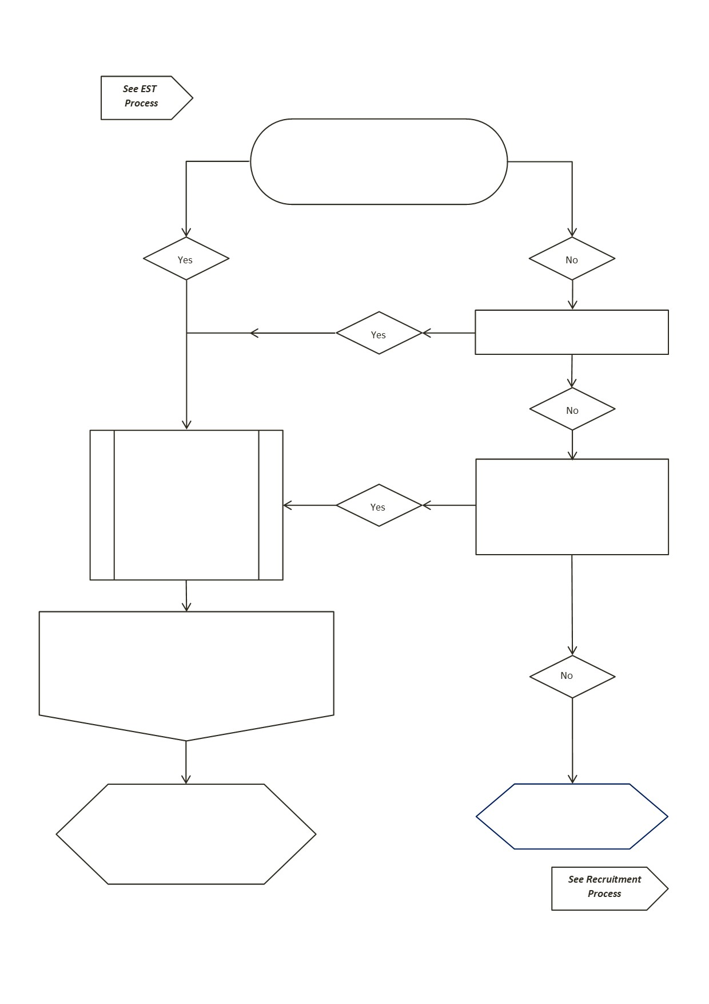
Is the post ‘NEW’ to the establishment structure/staffing complement?
Has the ‘Substantive’ post holder left their post on a permanent basis?
Is the request to backfill the post on a temporary basis?
(Maternity Cover and temporary arrangements of less than 2 years do not need to be resized)
Head Teacher/ Head of Education to complete and sign a Job Sizing Questionnaire (JSQ) & submit to Job Sizing Coordinators (JSC): jobsizing@eastlothian .gov.uk for review
Once content/R&Rs agreed by discussions between JSC & HT/HoE, JSQ content to be uploaded to SNCT Sizing Toolkit by the JSCs and the outcome grade generated. JSC’s will communicate the outcome to the HT/ HoE (& Business Support for DHT/HT recruitment).
JSC’s will email the resultant outcome (new post) to the Service Review Team, and any grade changes to Schools Finance and the relevant HR Advisor.
Posts undertaken on a temporary basis are not eligible for review
APPENDIX 2
Job Sizing Process – New or Vacated Posts

See Creating a New Post – Service Review policies

No
Yes
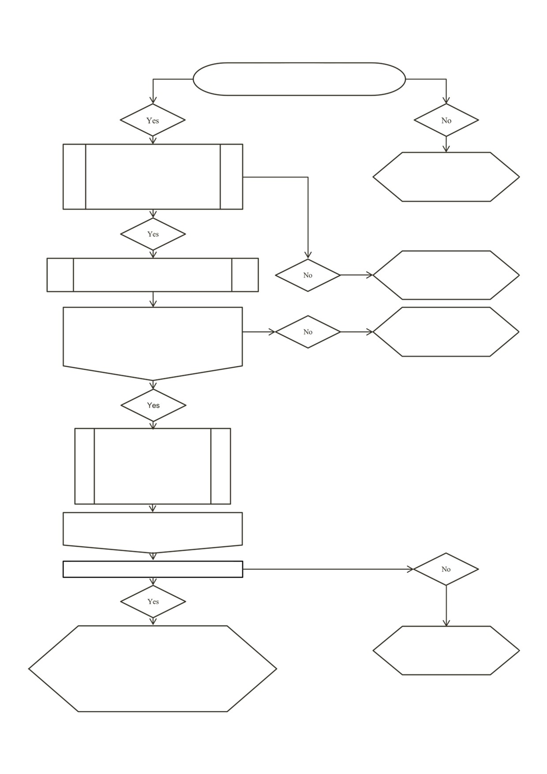
https://www.snct.org.uk/wiki/index.php?title=Appendix_2.2_Annex_A
APPENDIX 4
Is the applicant the substantive postholder?
Posts undertaken on a temporary basis are not eligible for review
Employee to complete the ‘Job Sizing Review Request Form’ and agree with HT/HoE that the review criteria are met.
Request closed. Not submitted to JSC.
Request closed. JSQ advise HT/HoE
Application form submitted to JSQ for review criteria validation.
JSCs review the JS Review Request
Are the criteria met?
JSCs request employee and HT/HoE jointly complete and sign a JSQ and submit to jobsizing coordinators for review.
JSCs upload the JSQ details to SNCT Sizing Toolkit to ascertain grade.
Is there a variance in the outcome grade?
JSC’s will email the resultant outcome to the HT/HoE and a COC should be completed by HT/HoE.
JSQ will advise changes to Schools Finance, the relevant HR Advisor and Service Review Team
Request Closed. JSC’s will email the resultant outcome to the HT/HoE
APPENDIX 3
Job Sizing Process – Postholder Request – Biannual Review

A Teaching Profession for 21st Century

JOB-SIZING QUESTIONNAIRE

HOW TO COMPLETE YOUR QUESTIONNAIRE

Who should complete the questionnaire? | This questionnaire should be completed by the following post holders:  - Head Teachers (HTs).  - Depute Head Teachers (DHTs).  - Principal Teachers (PTs).  - Any other Promoted Posts on SNCT Pay Scales (e.g. Educational Psychologists and Quality Improvement Officers)
Which sections of the questionnaire should I complete?  Do not complete the greyed-out part of Section 1. | DHT and PT post holders should complete all relevant sections of the questionnaire where these are applicable to the post held.  HT post holders should complete:  - Question 2.4 (where applicable).  - Questions 3.3 and 3.5 (where applicable).  The responsibilities of HTs relating to Section 1 of the questionnaire are determined by “whole school” information which will be provided by the Education Division.

APPENDIX 5

Review Criteria

Question  As set out in the job-sizing questionnaire | Change in responsibilities  either increases or decreases | Type of Change |  | Posts affected
- WHOLE SCHOOL/POST HOLDER INFORMATION
1.4 Type of Post | Change(s) to the allocation of responsibilities for formally deputising for the Head Teacher/Senior Manager amongst DHTs in the school. | A | DHTs
 | Change(s) in number of schools in which Head Teacher/Senior Manager posts have responsibilities. | A | HT
 | Change(s) in number of schools in which other posts have responsibilities. | B | DHT/PT
1.9 Type of Establishment | The addition or removal of an SEN Unit/Classes or the addition or removal of a Nursery Unit / Classes. | A | HT
1.10 School Roll (based on the September census of the previous school year) | Change(s) consisting of:  - +/- 100 pupils, or +/- 10% of the school roll on which the last job-sizing was based,  which leads to a change in the school roll band in the job-sizing toolkit. | A | All
1.11 Numbers of Staff | Change(s) consisting of:  - +/- 10 FTE staff, or +/- 15% of the numbers of FTE staff on which the last job-sizing was based. | B | HT/DHT
1.12 % of Children registered for free school meals | Change(s) consisting of:  - +/- 10% of the total numbers of pupils in the school,  which leads to a change in the free school meals band in the job-sizing toolkit. | B | All
1.13 Size of school budget | Change(s) consisting of:  - +/- £100,000 or +/- 20% of the regular annual revenue budget on which the last job-sizing was based  which leads to a change in the whole school budget band in the job-sizing toolkit. | B | HT
1.14 Physical nature of school | Becoming or ceasing to be a multi-site school. | B | HT/DHT
 | Change(s) consisting of +/- 100 pupils transported into school. | C | HT/DHT
Question  As set out in the job-sizing questionnaire | Change in responsibilities  either increases or decreases | Type of Change | Posts affected
- RESPONSIBILITY FOR THE LEADERSHIP, GOOD MANAGEMENT AND STRATEGIC DIRECTION OF COLLEAGUES
2.1 Direct line management responsibility for teaching staff | Change(s) consisting of:  - +/- 3 FTE teaching staff  which leads to a change in teaching staff FTE band in the job-sizing toolkit. | A | DHT/PT
2.2 Direct line management responsibility for other staff | Change(s) consisting of:  - +/- 3 FTE other staff  which leads to a change in the band in the other staff FTE band job-sizing toolkit. | A | DHT/HT
2.3 Accountability for budgets | Change(s) consisting of:  - +/- £5,000 or +/- 2-% of the regular annual revenue budget on which the last job-sizing was based  which leads to a change in the budgets band in the job-sizing toolkit. | B | DHT/PT
2.4 Responsibility for health and safety | Change(s) in responsibilities which leads to fewer or additional entries being made for this question in the job-sizing questionnaire. | C | All

Question  As set out in the job-sizing questionnaire | Change in responsibilities  either increases or decreases | Type of Change |  | Posts affected
- RESPONSIBILITY FOR THE CURRICULUM DEVELOPMENT AND QUALITY ASSURANCE
3.1 To review the CPD needs, career development and performance of colleagues | None required – covered by 2.1 and 2.2 above. | N/A | DHT/PT
3.2 To produce and implement the school development plan | Change(s) in responsibilities leading to fewer or additional entries being made for this question in the job-sizing toolkit. | C | DHT/HT
3.3 To develop the curriculum and monitor learning and teaching | Change(s) consisting of:  - +/- 5 classes.  - +/- 1 subject or +/- 2NQLs | B  C | DHT/PT  All  All
3.4 Other formal curricular/management responsibilities | The addition or removal of whole school responsibility for learning/behavioural support.  The addition or removal of any other responsibility listed in question 3.4. | A  B | DHT/PT  DHT/PT
3.5 Timetabled teaching time per week | +/- 10 hours  +/- 5 hours | B  C | All  All

- RESPONSIBILITY FOR WHOLE SCHOOL POLICY AND IMPLEMENTATION
4.1 To develop, manage and implement a policy on pupil behaviour management | Change(s) in responsibilities leading to fewer or additional entries being made for this question in the job-sizing toolkit. | C | DHT/PT
4.2 To develop, manage and implement a policy on guidance, pastoral care and pupil welfare | Change(s) in responsibilities for guidance, pastoral care or pupil welfare leading to fewer or additional entries being made for this question in the job-sizing toolkit. | C | DHT/HT
 | Change(s) to formal guidance responsibility consisting of +/- 25 pupils in the guidance caseload which leads to a change of:  - 2 bands in the job-sizing toolkit.  - 1 band in the job-sizing toolkit. | B  C | DHT/PT  DHT/PT  DHT/PT
4.3 To develop, manage and implement a policy on pupil assessment | Change(s) in responsibilities leading to fewer or additional entries being made for this question in the job-sizing toolkit. | C | DHT/PT

Question  As set out in the job-sizing questionnaire | Change in responsibilities  either increases or decreases | Type of Change |  | Posts affected
- RESPONSIBILITY FOR WORKING WITH PARTNERS
5.1 To work with parents | Change(s) in responsibilities leading to fewer or additional entries being made for this question in the job-sizing toolkit. | C | DHT/PT
5.2 To lead or work with colleagues in the same establishment | Change(s) in responsibilities leading to fewer or additional entries being made for this question in the job-sizing toolkit. | C | DHT/HT
5.3 To develop the curriculum and monitor learning and teaching | Change(s) consisting of:  - +/- 5 classes.  - +/- 1 subject or +/- NQLs | B  C | ALL  ALL
5.4 Other formal curricular / management responsibilities | The addition or removal of whole school responsibility for learning/behavioural support.  The addition or removal of any other responsibility listed in question 3.4. | A  B | DHT/PT  DHT/PT
5.3 To work with other establishments and agencies | Change(s) in responsibilities leading to fewer or additional entries being made for this question in the job-sizing toolkit. | C | ALL

APPENDIX 6

JOB SIZING REQUESTS – IDENTIFYING CRITERIA FORM
POST HOLDER DETAILS
Post Holder Name |  |  | Post Holder Title
Post Holder School |  |  | Post Holder Current Grade
PLEASE SELECT THE REASON(S) FOR THE REQUEST TO REVIEW THE POST GRADE IN CONJUNCTION WITH SNCT CRITERIA (please review the full details in SNCT PART 2 APPENDIX 2.3: ANNEX A REVIEW CRITERIA)

CHANGE CRITERIA | Tick  () |  |  | CHANGE CRITERIA |  |  |  | Tick  ()
1. WHOLE SCHOOL/POST HOLDER INFORMATION
1.4. Type of post |  |  |  |  | 1.12. % of children registered for free school meals
1.9. Type of establishment |  |  |  |  | 1.13. Size of school budget
1.10. School Roll (using the most recent census data submitted) |  |  |  |  | 1.14. Physical nature of school
1.11. Numbers of staff
2. RESPONSIBILITY FOR THE LEADERSHIP, GOOD MANAGEMENT AND STRATEGIC DIRECTION OF COLLEAGUES
2.1. Direct line management responsibility for teaching staff |  |  |  |  | 2.3. Accountability for budgets
2.2. Direct line management responsibility for other staff |  |  |  |  | 2.4. Responsibility for health and safety
3. RESPONSIBILITY FOR CURRICULUM DEVELOPMENT AND QUALITY ASSURANCE
3.1. To review the CPD needs, career  development and performance of colleagues |  |  |  |  | 3.4. Other formal curricular / management responsibilities
3.2. To produce and implement the school  development plan |  |  |  |  | 3.5. Timetabled +/- 10 hours teaching time per week
3.3. To develop the curriculum and monitor learning and teaching
4. RESPONSIBILITY FOR WHOLE SCHOOL POLICY AND IMPLEMENTATION
4.1. To develop, manage and implement a policy on pupil behaviour management
4.2. To develop, manage and implement a policy on guidance, pupil support, pastoral
care and pupil welfare
4.3. To develop, manage and implement a policy on pupil assessment

CHANGE CRITERIA | Tick  () |  | CHANGE CRITERIA |  |  | Tick  ()
5. RESPONSIBILITY FOR WORKING WITH PARTNERS
5.1. To work with parents |  |  |  | 5.3. To work with other establishments and agencies
5.2. To lead or work with colleagues in the same establishment
Have you discussed this request to review your post with your Head Teacher? YES NO
Post Holder Signature Date

Head Teacher Signature Date
PLEASE FORWARD THIS FORM TO THE JOB SIZING TEAM BY EMAIL TO jobsizing@eastlothian.gov.uk
FOR COMPLETION BY THE JOB SIZING TEAM

Date Received Criteria Met YES NO
Post Holder Advised of outcome YES NO
Date .
Head Teacher Advised of outcome YES NO
Date .
Questionnaire Sent to Post Holder YES NO

Job Sizing Review Request Form - March 2016

APPENDIX 7

JOB-SIZING OF PROMOTED TEACHER POSTS
Frequently Asked Questions on the Completion of Forms

 | Question | Answer
1. | Does number of children with transport to school mean entitled children only? | It does mean children who require assisted transport only, it is not a request for the total number of children who use school bus transport.
2. | In 2.1 and 2.2 what if FTE numbers fall  between two boxes? | Round up to the nearest whole number
3. | Should all Curricular PTs tick a box “other  direct curricular responsibilities” in  question 2.4? | If a PT has direct curricular responsibility for undertaking risk assessments (as defined in guidance) then they should tick one of the first two boxes in 2.4, depending on the subject for which they are responsible.
4. | Are boxes aggregated in the weighting system? | In questions 2.4, 3.2 and all of sections 4 and 5 boxes are not aggregated and the box ticked that  attracts the highest score will be taken.
5. | I am a DHT in primary with responsibility for the nursery and early stages, how should I complete this section? | 3.3 may be answered for HT, DHT or PT posts, provided the post has direct responsibility for the curriculum of the classes shown and for monitoring learning and teaching in these classes. Only one promoted post holder in a school can record responsibility for a class or classes in this section. Therefore as a DHT in primary with responsibility for nursery and P1-3 these classes should only be counted against your post and no other DHT, PT or the HT posts.
6. | I am a PT in secondary with responsibility for teaching S1-S6 classes. In S4,5 and 6 I teach certificated classes, how do I enter these on the questionnaire (3.3)? | Only national qualifications, national certificates, national courses (collections of units), on the authorised SQA list (e.g. including foundation apprenticeships) count in this column. Individual units do not. Each level should be counted only once and placed against the year group with the biggest presentation. Therefore if you have responsibility for classes at Higher in S4 and S5, the NQ will only be awarded once. All classes will be counted.

 | Question | Answer
7. | How do I account for nursery classes when responding to question 3.3? | Traditional morning/afternoon classes are simple: 1 class = 1 discrete group  The 1140 models can be complex, with shared spaces and hybrid models. E.g. Monday - Wednesday; Wednesday - Friday (2.5 days each); Monday – Thursday (4 shorter days) = 3 discrete groups BUT there could be 60+ in each group. To circumvent this we will assess each situation, but as a rough guide 25 pupils = 1 class.
8. | A faculty PT will be responsible for several departments, for example PE, HE & RME.  PE & HE are taught in practical sets and RME in class sets.  How many classes are entered in 3.3 for each year of the BGE (S1-S3)? | There are three clear subjects here.  Students should not be double counted – each child should only be counted once in each faculty. In this example if 11 practical sets and 8 class sets, we would accept the higher of the two – 11 “classes”.  Note not 11 + 11 + 8 = 30
9. | In 3.3, from S3 onwards PE and RME split into Core and Elective subjects. How many subjects and classes can I claim here? | PE & RME will only count once each as subjects– 2 subjects.  After subject choices have been made, the groupings are likely to be different for each subject and each elective class should be counted separately.  However, at this point counting each Core class will result in double counting (as in S1/S2) so should not be included.
10. | In a modern languages department a PT may be responsible for three languages. This would require an entry of three in  subject responsibility in 3.3. There may be three national qualifications within  each subject. Can we clarify if this should be entered as 9 or 3 in the number of qualifications section? | The national qualifications box should include the total number of national qualifications for which pupils are presented for all subjects in which the  post holder has direct curricular responsibility. Therefore, in this example, 9 should be entered in  the number of qualifications box.
11. | In primary schools, members of the SMT  may have a curricular responsibility for the whole school e.g. maths or language or expressive arts as well as having year group responsibilities. How are these classes counted for the purposes of Q3.3? | In primary, question 3.3 is usually simple in that post holders should enter the number of classes for which they are directly responsible for curriculum development & monitoring learning and teaching.  In some cases % allocations may be appropriate, e.g. 25% each. Divide total classes by 4. Enter the number of classes anywhere, except Nursery.  It is essential to ensure that the same classes are not counted twice.

 | Question | Answer
12. | In departments of special education in secondary schools, e.g. a special provision or a separate unit, PTs are responsible for all curriculum subjects. How should they complete section 3.3? | E.g. If a PT SfL has sole responsibility for the curricular materials and quality of learning and teaching for a separately timetabled group of pupils across S1 to S4, e.g. leading to presentation for English at N2 and N3 then a 1 should be entered in the subject column for S1 to S4 (where the responsibility for the subject is not shared with a PT English) and a 2 should be entered in the national qualifications column either against S3 or S4 (but not both).  No entry should be made in column for number of timetabled classes. The class responsibility is covered in question 3.4 and the box “Responsible for an ASfL unit, hub, class or group for which no other promoted postholder is responsible” should be ticked.
13. | Apart from those in 3.4 what other boxes should be ticked for learning/behavioural support roles? | We would expect to see behavioural support roles tick a box in 4.1 and learning support would probably tick a box in 4.3. However, this could  vary depending on how these responsibilities are managed in each school. There can be no duplication.
14. | Can responsibilities be duplicated in different sections of the form? | Whole school responsibilities can only be claimed by one promoted post, except section 3.4 where learning and/or behavioural support can be split.  Where responsibilities can be attributed to discrete groups, care must be taken not to double count students. E.g. responsibility has been claimed by DHTs by year group/level, covering the whole school, no further credit can be granted for subsets of students or staff.
15. | As a DHT/PT I make myself available at parents’ evenings, does this constitute additional responsibilities in working with parents/carers? | All promoted posts have a responsibility for working with partners (parents/colleagues/external agencies). All posts are awarded a base score for this which is calculated from the whole school data. So no, this is part of your Roles & Responsibilities.  Any responsibilities listed in Section 5 can only relate to responsibilities not already captured by previous questions. E.g.there is an expectation that Curricular PTs will speak to parents and colleagues about their subject but may perform additional duties in this regard.

Part 2: Appendix 2.2, Annex
APPENDIX 8

JOB SIZING QUESTIONNAIRE

Please refer to the ‘Job Sizing Notes of Guidance and Examples’ when completing this questionnaire.

SECTION 1: WHOLE SCHOOL INFORMATION

Questions 1.1 to 1.7 should be completed for all posts.

1.1 Name of Council

(Management)
(Teacher Union)
1.2 Names of Job Sizing Co-ordinators

1.3 Name(s) of
School(s)/Service

1.4 Type of Post

- Please tick the box which applies.

Headteacher (HT)

Depute Headteacher (DHT)

Principal Teacher (PT)

- Please tick any box which applies and provide information where requested.

The responsibilities of the post relate to more than one school

Enter the number of schools

The post is a part time post

Enter the number of contracted hours worked per week (35 hours equals full time)

Part 2: Appendix 2.2, Annex A, Job Sizing
Questionnaire

• Please tick any box which applies and provide information where requested.

The post is an established part of the Senior Management Team (SMT)
The post is the only post with responsibility for formal deputising for the HT (i.e. the formal depute)
The post is part of a SMT that does not include a formal depute

If the SMT does not include a formal depute, enter the number of established SMT posts in the school (excluding the HT)

1.5 Title of Post

1.6 Name of post holder
(Resizing applications only)

Female
1.7 Gender of post holder Male
(Resizing applications only)

Questions 1.8 to 1.14, pages 3 to 5, will be completed by the job sizing co-ordinators. Post holders must not complete these questions.

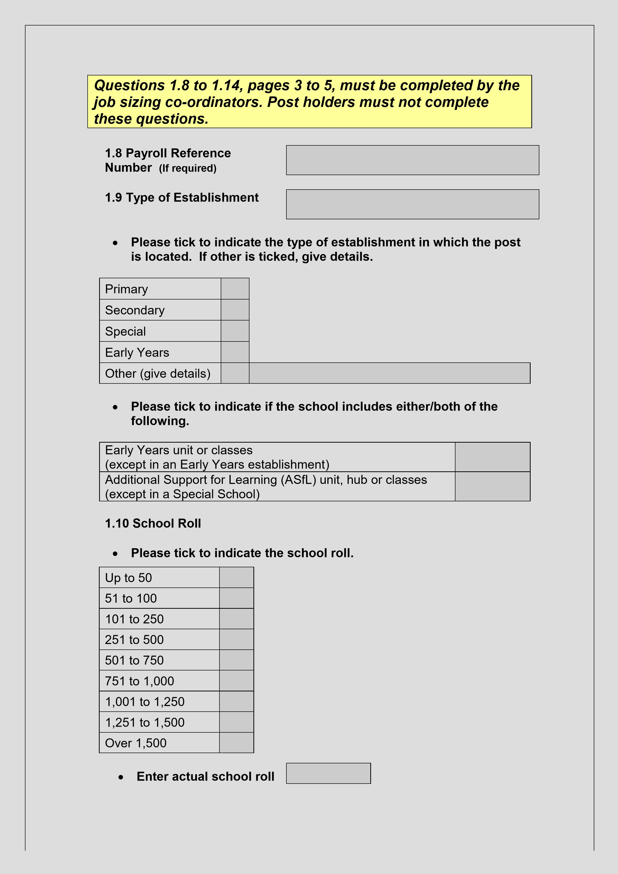
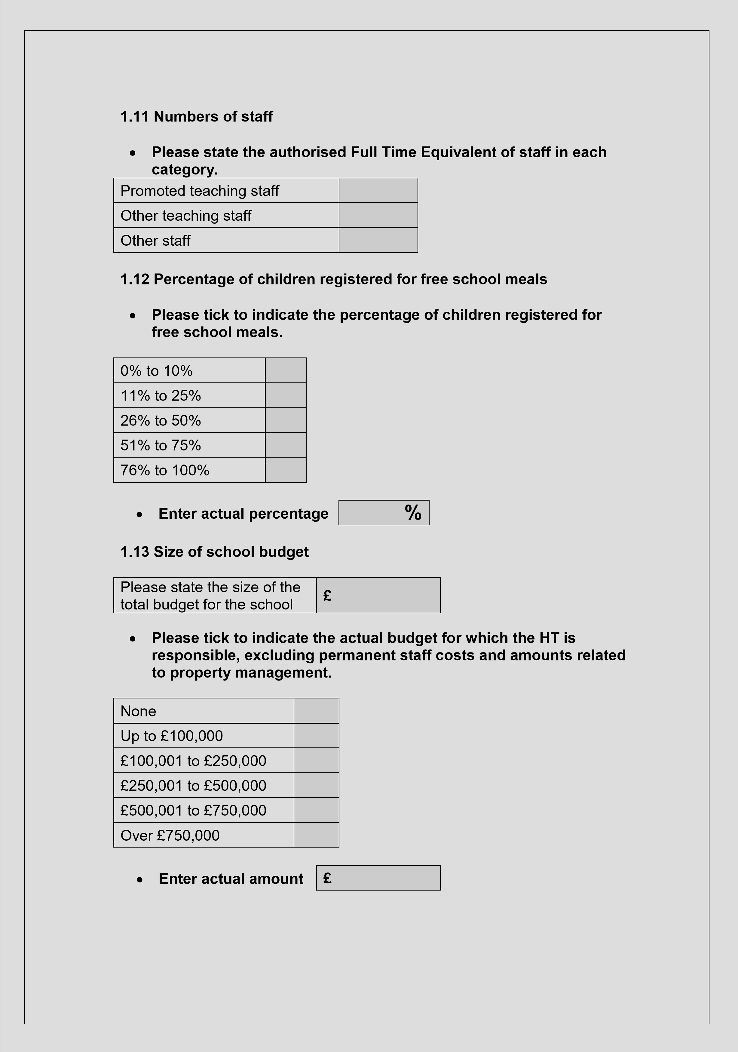
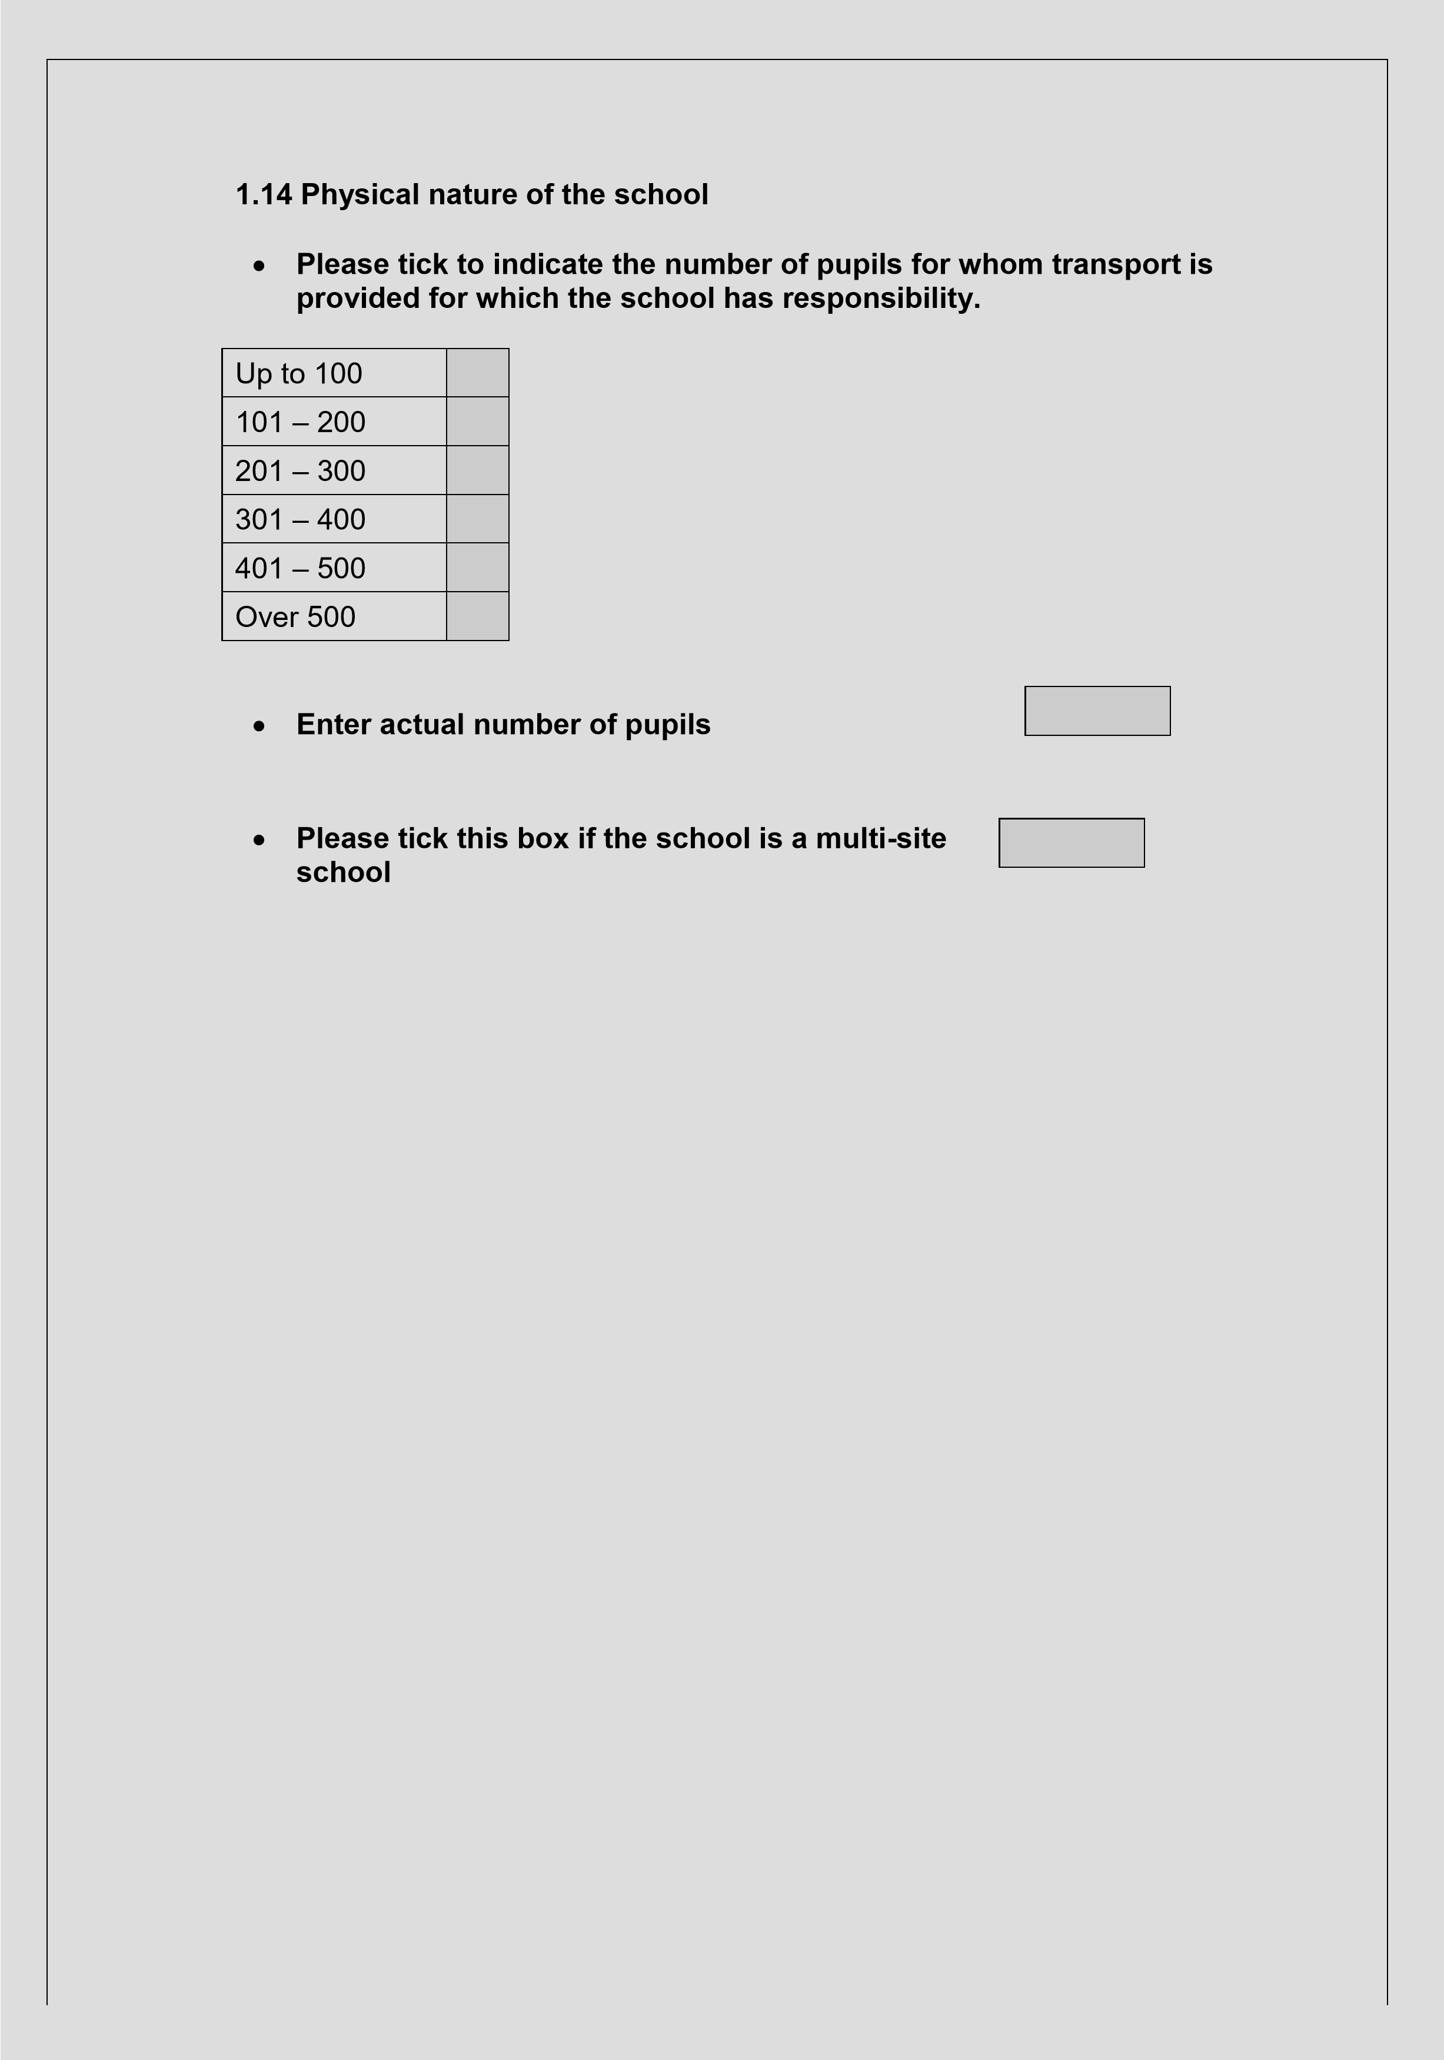

SECTION 2: RESPONSIBILITY FOR THE LEADERSHIP, GOOD
MANAGEMENT AND STRATEGIC DIRECTION OF COLLEAGUES
Questions 2.1 to 2.3 should be completed for DHT and PT posts only.

2.1 Direct line management responsibility for teaching staff

- Tick the relevant box in the left column below for the total number of teaching staff for whom the post has line management responsibility.

- Tick the relevant box in the right column for the total FTE of staff to reflect any part time staff or those staff who are line managed by the post on a pro rata basis.

Total Number of  Teaching Staff | FTE

None

1

2 to 5

6 to 10

11 to 25

26 to 50

Over 50

• Enter actual FTE

2.2 Direct line management responsibility for other staff

- Tick the relevant box in the left column below for the total number of support staff for whom the post has line management responsibility.

- Tick the relevant box in the right column for the total FTE to reflect any part time staff or those staff who are line managed on a pro rata basis.

Total Number of Staff FTE

None

1

2 to 10

11 to 25

Over 25

• Enter actual FTE

DETAILS:

2.3 Responsibility for budgets

- Tick the relevant box for the amount of regular annual budget for which the post is accountable.

None

Up to £1,000

£1,001 to £5,000

£5,001 to £10,000

£10,001 to £25,000

Over £25,000

£
- Enter actual budget

2.4 Responsibility for health and safety

This question applies to all posts. HTs may tick the 4th box but only where the HT post has responsibility as the school’s Health and Safety Officer.

- Tick the relevant box below for the curricular area or category for which the post has overall health and safety responsibility:

Direct curricular responsibility for Craft, Design and Technology;
Physical Education (including outdoor activities); Chemistry; Physics;
Biology; Home Economics or Art and Design

Other direct curricular responsibilities

Year groups and / or specialist sections of the school

The whole school (i.e. school’s Health and Safety Officer or equivalent)
SECTION 3: RESPONSIBILITY FOR CURRICULUM DEVELOPMENT AND
QUALITY ASSURANCE

3.1 To review the CLPL needs, career development and performance of colleagues

A score is automatically awarded for this responsibility based on the entries made in questions 2.1 and 2.2. There is no need to enter any further data.

3.2 To produce and implement the school improvement plan and responsibility for whole school policies

This question should be completed for DHT and PT posts only.

• Please tick as many boxes as apply and add details in the text box below.

Responsible for producing and leading some or all of a curricular, departmental, subject or faculty improvement plan each year

Responsible for producing and leading some or all of an improvement plan relating to pupil guidance, pupil support or pupil welfare each year

Responsible for producing and leading some or all of an improvement plan relating to specified stages, year groups, other specified groups of pupils, or other specific responsibilities each year

Responsible for producing and leading the whole-school improvement plan, and/or sole responsibility for specified whole school policies each year, whether or not under review in the improvement plan

DETAILS:

3.3 To develop the curriculum and monitor learning and teaching

This question applies to all posts.

No details of curricular areas or national qualifications are required for Early Years and Primary sectors. Note: The total number of classes entered across all promoted post holders in a school must not exceed the number of classes in the school.

- Please enter number of classes:

Stage or Year Group | Number of Timetabled Classes
Early Years
P1
P2
P3
P4
P5
P6
P7

- Please enter numbers and text below as required:

Note: In relation to National Qualifications, only national courses (collections of units), national certificates and national qualifications count in this column. Individual units do not. Each level should be counted only once and placed against the year group with the biggest presentation.

 |  | Names of Subjects | Number of  Subjects | Level of National Qualification  (NQ) | Number  of NQs | Number of  Timetabled Classes
 | S1
 | S2
 | S3
 | S4
 | S5
 | S6

3.4 Other formal management responsibilities

This question should be completed for DHT and PT posts only.

• Please tick as many boxes as apply and add details in the text box below.

Responsible for the whole school timetable in a Secondary school

Responsible for whole school ICT development to support teaching and learning
Responsible for pre-5 / Early Years classes in a Primary school

Responsible for learning and/or behavioural support

Responsible for an ASfL unit, hub, class or group for which no other promoted post holder is responsible
Responsible for other identifiable whole school groups of pupils for which no other promoted post holder is responsible
Head of a discrete section of a combined school

DETAILS:

3.5 Timetabled teaching time

This question applies to all posts.

• Please enter, to the nearest hour, the weekly timetabled class teaching commitment which is undertaken as a requirement of the post.

Teaching time | hours
SECTION 4: RESPONSIBILITY FOR WHOLE SCHOOL POLICY AND
IMPLEMENTATION

All questions in this section may be completed for DHT and PT posts only. For a PT post with curricular responsibility only complete question 4.3 but do not complete questions 4.1 and 4.2.

4.1 To develop, manage and implement a policy on pupil behaviour management

- Please tick to indicate the specific responsibilities of this post in relation to pupil behaviour management and provide details below.

Responsibilities for behaviour management relating to specified stages or year group(s) or specialist section(s)

Responsibilities for behaviour management policy relating to the whole school

DETAILS:

4.2 To develop, manage and implement a policy on guidance, pupil support, pastoral care and pupil welfare

- Please tick to indicate the specific responsibilities of this post in relation to guidance, pupil support, pastoral care and pupil welfare and give details below.

Formal guidance, pupil support, pastoral care responsibilities with an identified caseload (Secondary schools only)
Responsibilities relating to the guidance, pupil support, pastoral care and pupil welfare of a year group and/or a specialist section(s) of the school
Responsibility for specified whole school policies on guidance, pupil support, pastoral care and pupil welfare
DETAILS:

Formal guidance/pupil support/pastoral care responsibilities with a caseload (Secondary schools only)

Please note that, for those posts with a formal guidance/pupil support/pastoral care role, the caseload indicated below will also be used to capture the guidance, pupil support and pastoral care responsibilities covered in other sections of this questionnaire.

None

1 to 50

51 to 100

101 to 200

Over 200

  - Enter actual number of pupils in caseload

4.3 To develop, manage and implement a policy on pupil assessment

- Please tick to indicate the specific responsibilities of this post in relation to pupil assessment and give details below.

Responsible for pupil assessment relating to a subject department or curricular area
Responsible for pupil assessment relating to a year group or specialist section
Responsible for pupil assessment policy relating to the whole school

DETAILS:

SECTION 5: RESPONSIBILITY FOR WORKING WITH PARTNERS

All questions in this section may be completed for DHT and PT posts only.

5.1 To work with parents/carers

- Please tick as many boxes as apply and add details in the text box below.

Responsible for remits that involve working with parents/carers on behalf of specified groups of pupils, for example stages, year groups and other identifiable groupings of pupils
Responsible for remits that involve working with parents/carers on behalf of pupils across the whole school
DETAILS:

5.2 To lead or work with colleagues in the same establishment

- Please tick as many boxes as apply and add details in the text box below.

Responsible for remits that involve leading or working with colleagues in the same establishment on behalf of specified groups of pupils, for example stages, year groups and other identifiable groupings of pupils
Responsible for remits that involve leading or working with colleagues in the same establishment on behalf of pupils across the whole school

DETAILS:

5.3 To work with other establishments and agencies

- Please tick as many boxes as apply and add details in the text box below.

Responsible for remits that involve working with other establishments and agencies on behalf of specified groups of pupils, for example stages, year groups and other identifiable groupings of pupils
Responsible for remits that involve working with other establishments and agencies on behalf of pupils across the whole school
Responsible for remits that require applying promoted responsibilities in other establishments or agencies
DETAILS:

SIGNATURES

Post Holder (Resizing Applications Only)

Signature: ________________  HT/Council Manager | Date: __________
Signature: ________________  Job Sizing Co-ordinators | Date: __________
Signature: ________________  (Management) | Date: __________
Signature: ________________  (Teacher Union) | Date: __________

SNCT QUESTIONNAIRE & GUIDANCE:

https://www.snct.org.uk/wiki/index.php?title=Appendix_2.2_Annex_A

